2004 International Workshop
on
Practice and Theory
in Public Key Cryptography

2- 4 March 2004

Singapore

FOR YOUR INFORMATION

Pre-Registration
Pre-registration is on 1 March at 2.00pm to 6.00pm at Rasa Suites 4 & 5 on Level 6. You may want to come by to pick up your conference bag with proceeding, or make payment for the banquets for your guests.

The Secretariat will be relocated to outside the Siloso 1 Ballroom from 2 March.
Conference Venue
Siloso 1 Ballroom at the Shangri-la’s Rasa Sentosa Resort. This ballroom is located on Level 1 (same level as the pool).

The Shangri-la’s Rasa Sentosa Resort will be referred to as the Hotel.

Admission Fee to Sentosa
There is a S$2.00 admission fee for every person to enter Sentosa. If you are booked with the Hotel, a confirmation of booking will be issued to you to waive this charge if you use the Hotel Shuttle Service, Taxi & Private Car*.

For local delegates, a copy of the confirmation letter will be faxed to your attention prior to the event.

You may be requested to show this booking confirmation at the Entrance to Sentosa.

* Private Car – Drive-in charge of S$2.00 still applies. To waive this charge, prior notice of vehicle number has to be submitted to patricia@i2r.a-star.edu.sg before 25 Feb 2004. Please note that
the same vehicle has to be driven on all the conference days.

Hotel Guests can obtain a re-entry slip from the Concierge to waive off the admission fee before traveling to Singapore.

Hotel Shuttle Service
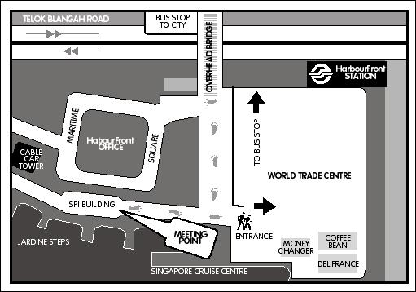
Pick-up point to the Hotel
via the hotel shuttle service
is as indicated.

Frequency of the shuttle
service is every 20 mins.

The first shuttle leaving
HarbourFront Centre is at
7.20am.

Conference Bags
As the conference room may be used for night functions, please DO NOT leave your bags behind at the end of each day. Lost of Conference Bags will not be replaced.

Conference Proceedings
Extra copy of the conference proceedings is available at the registration desk at a cost of S$85.

Valuables
We request that you do not leave any valuables unattended in the conference room or any public area in the premises of the event venue.

FOR YOUR INFORMATION

Name Badge
Delegates are requested to wear the name badge at all time during the conference, lunches, welcome reception and banquet.

Message Board
We are unable to interrupt the proceedings with telephone messages. However, all messages received will be pinned on the notice board outside the conference room.

Lunches
2 March 2004
1230 – 1400 Chinese Set Lunch at The Pavilion, Level 5.

3 March 2004
1230 – 1400 International Buffet at Silver Shell Café, Level 3.

4 March 2004
1230 – 1400 International Buffet at Silver Shell Café, Level 3.

Partners / spouses who would like to join us for lunch and tea-breaks will be charged at S$82** per day per person.

Functions^
The Welcome Reception and the Dinner Banquet are open to all delegates.

Welcome Reception, 2 March 04
This event is held at The Ballroom at The Sentosa Resort & Spa, Beaufort which is not in the Hotel premises.

A bus will leave for The Sentosa Resort & Spa, Beaufort, promptly at 6.30pm. All delegates are to wait at the Hotel Lobby.

Return trip to The Hotel: A bus will leave The Sentosa Resort & Spa, Beaufort, at 10.00pm to return to Rasa Sentosa Hotel. All delegates are to wait at the Lobby for the shuttle.

Partners / spouses who would like to join us will be charged at S$116** per person.

Conference Dinner Banquet (Outdoor Event), 3 March 04
The banquet, in the form of a barbeque, is held at the Waterfront, Level 1.

Welcome drink is served at 6.30pm. Dinner starts around 7.00pm. Do bring along your camera to capture the sunset.

Partners / spouses who would like to join us will be charged at S$128** per person.

Mobile Phone and Pagers
Kindly switch your mobile phone and pager to silent mode during the conference so as to minimise interruptions to the proceedings.

^ RSVP: patricia@i2r.a-star.edu.sg (see attached Form)
(Pls do so by 25 Feb as we need to confirm the numbers with the hotel.)

** Payment to be made by 2 March by Visa/MasterCard (in Singapore dollars) or Singapore dollars only.

RSVP

You may email this form as an attachment to patricia@i2r.a-star.edu.sg or fax to: (65) 775 9923.

Name: _______________________________________________

Company: ____________________________________________

- I will be attending the Welcome Reception.
- I will not be attending the Welcome Reception.

- I will be bringing _________ guests to the Welcome Reception.

  - Specify dietary requirement for guest/s if any: ____________________
  - Payment to be made by 2 March 2004.

- I will be attending the Dinner Banquet.
- I will not be attending the Dinner Banquet.

- I will be bringing _________ guests to the Dinner Banquet.

  - Specify dietary requirement for guest/s if any: ____________________
  - Payment to be made by 2 March 2004.

